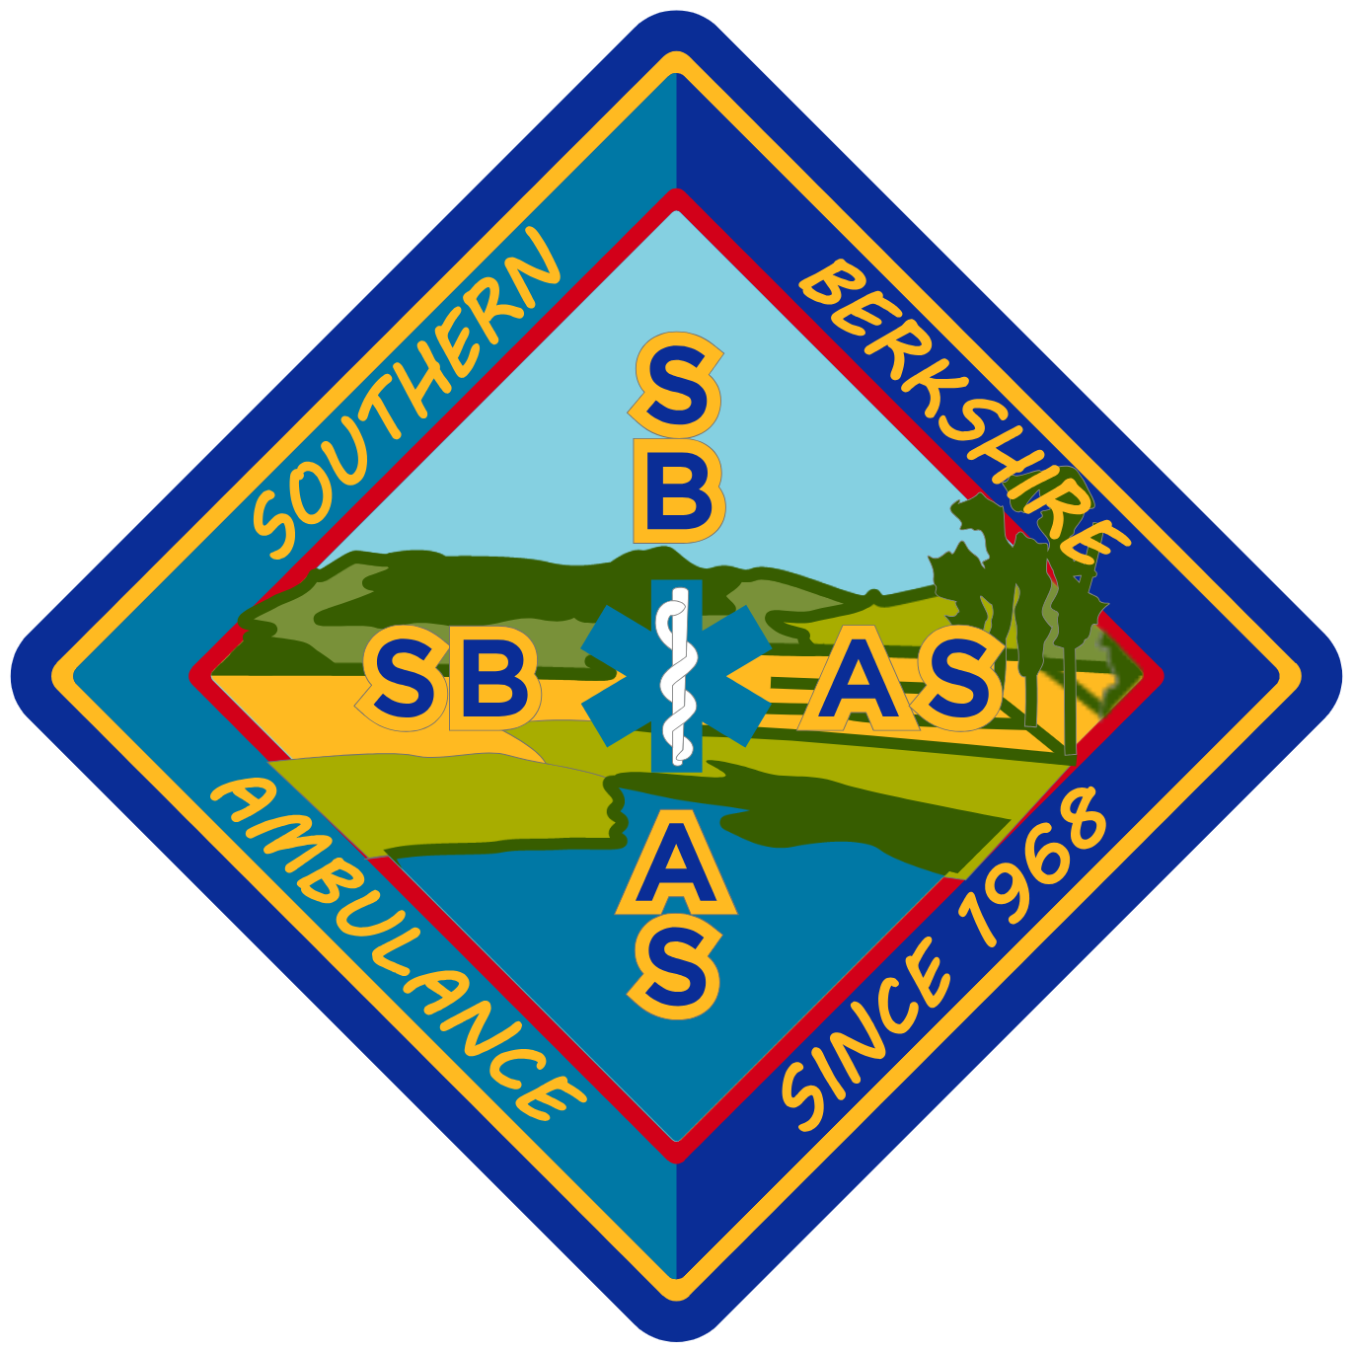
SOUTHERN BERKSHIRE AMBULANCE SQUAD
EMT TRAINING PROGRAM · APPLICATION FOR ADMISSION

Incomplete applications will not be processed.
Preference will be given to candidates with an interest in employment at Southern Berkshire Ambulance.
Please print legibly and use black or blue ink only.
Training program applying for: ☒ EMT — Fall 2026

Demographic Information

Full Name (Last, First, MI) | Date of Birth

Last 4 digits of Social Security Number: XXX – XX – ______ (required for NREMT psychomotor exam registration)
Street Address | Apt #

City | State | Zip Code

Telephone | Cell Phone | E-Mail

Current Place of Employment | Employer Telephone / Ext.

Employer's Address (Street, City, State, Zip)

Have you ever enrolled in an EMT training program before? If yes, where and when?

Have you ever pled "guilty" or "no contest" to, or been convicted of, a crime? If yes, please briefly describe.

Educational Background

Level of Education | Years Completed | Did you Graduate? | Course of Study | Degree Received
High School or G.E.D.
College (Undergraduate)
College (Graduate)
Prior EMT Program
Other

Certifications & Licenses

Current VALID certifications / licenses held: ☐ Driver's License ☐ CPR ☐ Other: ______________________________
Please include with your application a 300–500 word explanation of why you wish to participate in our EMT program.

Emergency Contact Information

Name | Relationship

Address (Street, City, State, Zip)

Phone Number(s) | E-Mail

Parent or Guardian Additional Indemnification

(Must be completed for participants under the age of 18.)
In consideration of ____________________________ (Minor) being permitted by SBAS to participate in its activities and to use its equipment and facilities, I further agree to indemnify and hold harmless SBAS from any and all claims which are brought by, or on behalf of, the Minor, and which are in any way connected with such use or participation by the Minor. Please note that you must be at least 18 years old to participate in the NREMT exam. Candidates have one year to complete the NREMT exam following course completion.
Parent / Guardian's Signature | Date | Print Name

Photo / Media Release

I grant SBAS Programs the right to use, reproduce, assign, and/or distribute photographs, films, video tapes, and sound recordings of me for use in materials they may create.
Signature | Date | Print Name

Parent / Guardian's Signature (if under 18) | Date

Participant Agreement, Release, and Assumption of Risk

In consideration of the services of Southern Berkshire Ambulance Service Training Programs, their agents, owners, officers, volunteers, participants, employees, and all other persons or entities acting in any capacity on their behalf (hereinafter referred to as SBAS), I hereby agree to release, indemnify, and discharge SBAS, on behalf of myself, my children, my parents, my heirs, assigns, personal representative, and estate as follows:
I acknowledge that my participation in group initiatives, problem-solving exercises, and personal or professional growth and development training — including clinical and field experiences for EMT students — entails known and unanticipated risks that could result in physical or emotional injury or death. I understand that such risks simply cannot be eliminated without jeopardizing the essential qualities of the activity.
The risks may include, among other things: strenuous physical activity; slips and falls; sprains and strains; inclement weather; other participants’ and/or my own negligence; and emotional stress.
Furthermore, SBAS facilitators have difficult jobs to perform. They seek safety, but they are not infallible. They might be unaware of a participant’s fitness or abilities. They may give inadequate warnings or instructions, and the equipment being used might malfunction.
I expressly agree and promise to accept and assume all of the risks existing in this activity. My participation in this activity is purely voluntary, and I elect to participate in spite of the risks.
I hereby voluntarily release, forever discharge, and agree to indemnify and hold harmless SBAS from any and all claims, demands, or causes of action which are in any way connected with my participation in this activity or my use of SBAS equipment or facilities.
Should SBAS, or anyone acting on their behalf, be required to incur attorney’s fees and costs to enforce this agreement, I agree to indemnify and hold them harmless for all such fees and costs.
I certify that I have adequate insurance to cover any injury or damage I may cause or suffer while participating, or else I agree to bear the costs of such injury or damage myself. I understand that SBAS does not provide health insurance for students of their courses. I further certify that I am willing to assume the risk of any medical or physical condition I may have.
By signing this document, I acknowledge that if anyone is hurt or property is damaged during my participation in this activity, I may be found by a court of law to have waived my right to maintain a lawsuit against SBAS on the basis of any claim from which I have released them herein. I also acknowledge that I have fully satisfied myself as to the nature of the activity or activities in which I will be participating, the risks associated with each such activity, and my responsibility to know my own limits. In the event of illness or injury, consent is hereby given to provide emergency medical care, hospitalization, or other treatment that may become necessary.
I have had sufficient opportunity to read this entire document. I have read and understood it, and I agree to be bound by its terms.

Signature | Date | Print Name

Application Submission Process

Upon completion, please submit this application by mail, fax, or scan-and-email to:
MAIL — USPS  Southern Berkshire Ambulance Squad  Attn: EMT Training Program  31 Lewis Avenue  Great Barrington, MA 01230 | EMAIL (SCAN)  ajanderson19@yahoo.com
FAX  (413) 528-5549 | QUESTIONS  AJ Anderson, Director of Training  413-854-7278  southernberkshireambulance.com/emt-training

Application deadline: August 21, 2026.
Tuition: $2,000 (not including testing fees). If accepted, a $500 deposit is required, with the remaining balance due by the first week of class.
Course dates: September 1, 2026 – February 18, 2027.

SBAS does not unlawfully discriminate on the basis of age, race, national origin / ancestry, color, sex, religion / creed, or handicap / disability. SBAS operates in accordance with applicable laws on equal opportunity and non-discrimination in the consideration for admission.
I hereby certify that, to the best of my knowledge, the information furnished on this form is true and complete without evasion or misrepresentation. I understand that if found to be otherwise, it is sufficient cause for rejection and/or dismissal.

Signature | Date | Print Name

Parent / Guardian's Signature (if under 18) | Date

